PROJECT REPORT
C PROGRAMMING

School of Computer Science
University of Petroleum and Energy Studies

PROJECT TITLE: RESTAURANT BILLING SYSTEM

SUBMITTED BY:
Name: Saranshi Chitra
SAP ID: 590027413
Batch no.60
Course Code: CSEG1041

SUBMITTED TO:
Instructor: Dr. Prashant Trivedi

ABSTRACT

It is a simple and efficient Restaurant Billing System. The code allows user to select food from the menu provided, converts the items in upper case, reconfirms the items ordered and then calculates the subtotals and generates the final bill including taxes. The objective is to automate billing system, reduce manual calculations and improves efficiency. The code contains basic concepts like functions, arrays, structures, conditional statements, looping statements etc. It is easy to use and accurate, reduce calculation errors, user friendly and efficient for future use.

PROBLEM DEFINITION

Restaurants often face issues like:
Manual billing errors.
Huge time consumptions.
Lack of service during peak hours.
Unable to store the details of items ordered.

This code develops a billing system ensuring:
Allows user to give order.
Calculates subtotals, taxes and final amount.
Stores details in variables.
Generates bill.
Saves times.

ALGORITHM

- Starts by greeting the customer.
- Prints Menu.
- Asks user to enter the order items.
- Converts all the items ordered in Upper case.
- Reconfirms the items ordered by the customer.
- Computes Taxes.
- Calculates total amount= Subtotal + taxes
- Generates bill and displays it.
- Thanking the customer for coming.

FLOWCHARTS

Start

Welcoming customer

Prints Menu

Takes input from the customer

Converts the input in upper case

Reconfirming order

Computes taxes and calculates total amount.

Prints bill

Printing message of thanking the customer

End

IMPLEMENTATION DETAILS

- Printing the menu
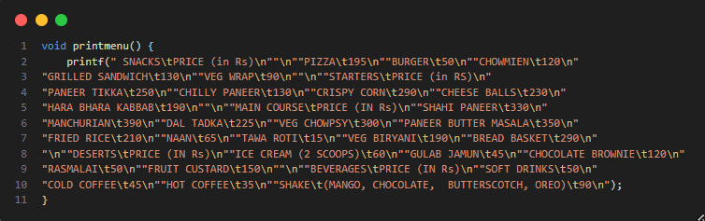

- Defining structure to store Item details
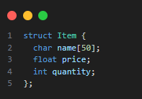

- Storing menu in a structure
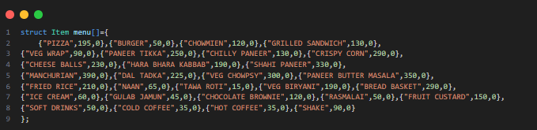
- Taking order
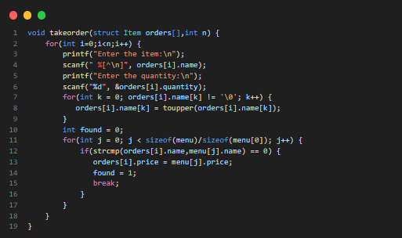

- Confirming the order
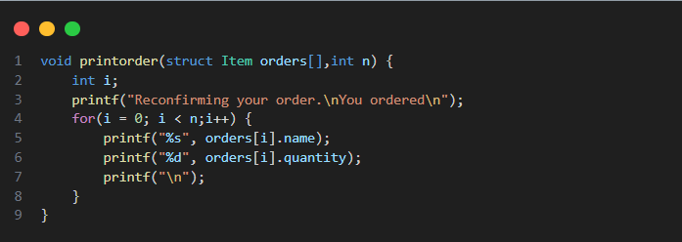

- Generating bill
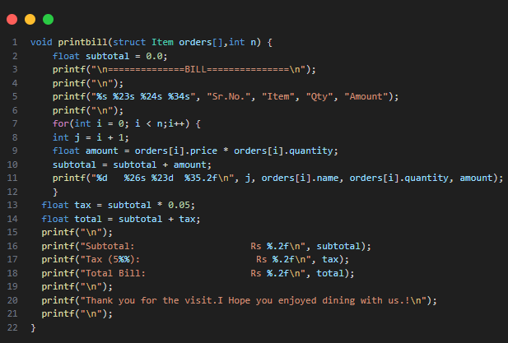

- Calling functions in main method
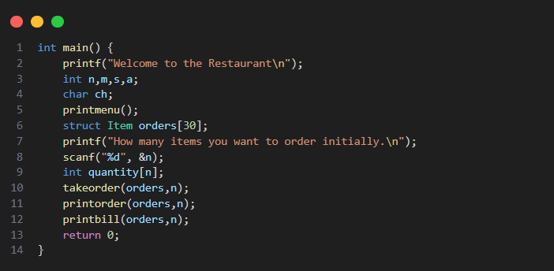
TESTING AND RESULTS

- Displaying menu in the terminal window
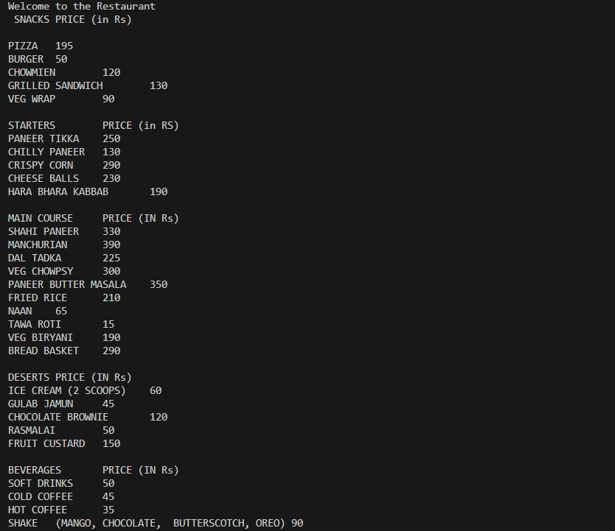

- Asking user to input the order and then confirming it
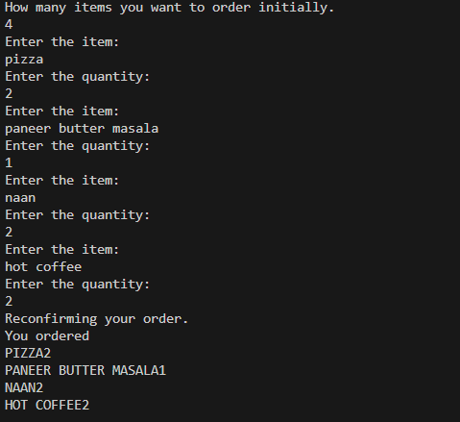

- Generating bill
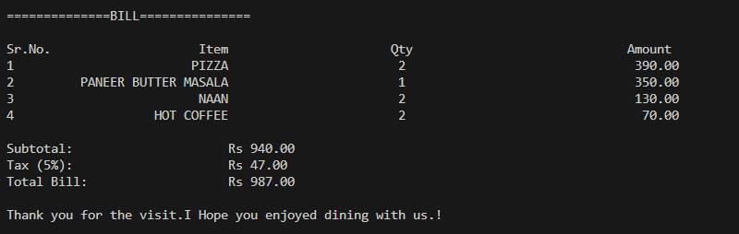

CONCLUSION AND FUTURE WORK

The Restaurant billing system successfully automates billing operations, reduces human errors and speeds up the billing process. It provides accurate calculations, easy order handling and simple interface for staff. The objective of this project is to demonstrate how digital solutions improve restaurant operations skilfully. It is simple to use and allows staff to generate bills accurately.

FUTURE WORK
- Integrate online ordering and mobile app.
- Implement inventory management.
- Provide multi user access with authentication.

REFERENCES

- Let Us C (YASHAVANT KANETKAR)
- YOUTUBE VIDEOS: https://www.youtube.com/watch?v=_2msghvRn5M&t=1463s&pp=ygUfcmVzdGF1cmFudCBiaWxsaW5nIHN5c3RlbSBpbiBjXA%3D%3D
https://www.youtube.com/watch?v=Lttd3ohTarE&list=PLBLPjjQlnVXVnz3Hksi1th0uHXxh6Dm3h

